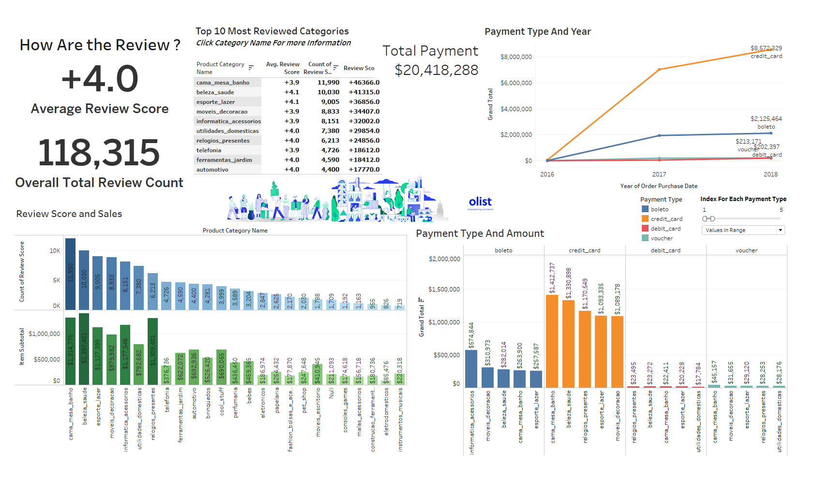

Review

* Overall reviews average for all products is 4.0 (Based on 118,315 review counts)
* Based on the review counts, we generated out the top 10 most reviewed categories, with their review averages and total review scores and their item subtotal (price \* number of item sold):
  + Bed Bath Table
  + Health Beauty
  + Furniture Decor
  + Computer Accessories
  + Housewares
  + Telephony
  + Garden Tools
  + Auto
* Review Score and sales graph shows how the growth of sales is aligning with the counts of review score. Even though we can’t conclude that review was directly affecting sales, but most customers left their reviews after they had their purchases.

Recommendation:

* Review score of 4, in 100% scale, is only 80%.
* Customers are only 80% satisfied with their shopping experiences in Olist, and their ordered products.
* It is recommended to have a seller improvement program (consulting) to improve customer service level.

Payment Type

* We have 4 payment types. From 2016 to 2018 the total payment received (freight + sales) is 20.4 million.
* Payment Growth with payment type shows the growth of each payment type yearly. Credit card is the most used payment type. A total payment received of 15.6 million from 2016 to 2018.
* Payment Type and Amount shows how the categories’ payment amount are in each payment type. As the bars show from CC section, the amount paid by are way higher than the other payment types.

Recommendations:

* Since CC’s usage grows exponentially over the years. Olist can consider launching their own credit card (co-branded cards) with incentive events or reward points…etc to increase sales.

<https://medium.com/@deelipku23/review-prediction-brazilian-e-commerce-dataset-7f4312e0e5d5>

<https://olist.com/branded-store/>

<https://labsnews.com/en/articles/business/olist-raises-brl-310-million-round-from-softbank-and-announces-clickspace-acquisition/>

<https://pitchbook.com/profiles/company/102473-65#competitors>